**Listening N° 1: How many school objects can you recognize?**

**Name: Class: Date:**

Escuchar y demostrar comprensión de información explícita en textos adaptados y auténticos simples, tanto no literarios como literarios que estén enunciados en forma clara, tengan repetición de palabras y apoyo visual y gestual, y estén relacionados con las funciones del año y con los siguientes temas:

* Temas de la vida cotidiana: la escuela.

**Objetivo de Aprendizaje 1**



**I. WATCH** the video and **WRITE** the name of each school object under the correct picture.

(Taken from: <https://www.youtube.com/watch?v=g7kK989HiRQ&t=24s>)

scissors – book – pencil case – ruler – eraser – pencil

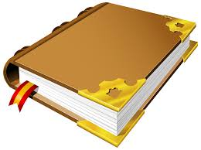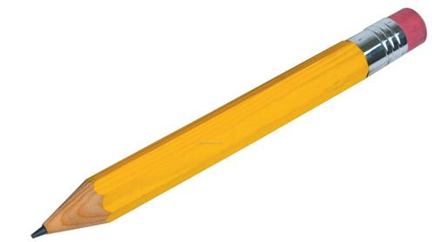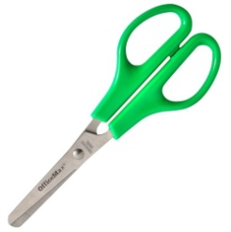

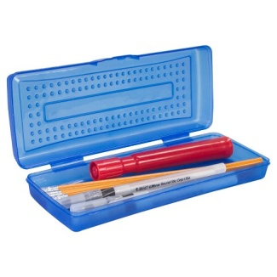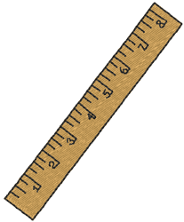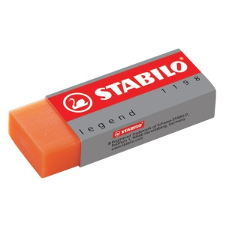

**II.** **WATCH** the video and **WRITE**  7 instructions that are mentioned.

(Taken from: https://www.youtube.com/watch?v=UIGD9uFY-C4&list=PLh2HfVOxx0v6FvD5NdORd9AqgZtu_zlzh)

a)

b)

c)

d)

e)

f)

**Image result for headphones logoIII. LISTEN**  to your teacher and **MATCH**  the pictures with the correct instruction. Then, **FOLLOW** your teacher’s instructions and mimic them.



1. Raise your hands

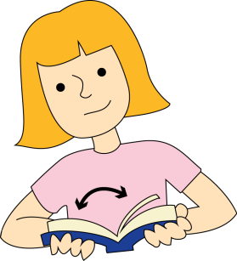

2. Listen to your teacher

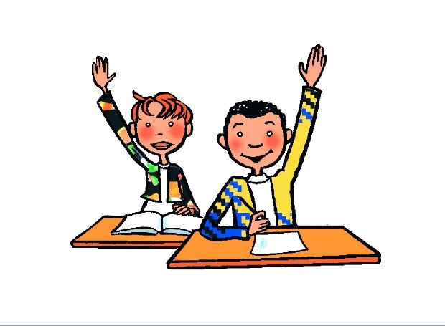

3**.** Look at the board

4. Open your book.



**4.** Open your book

**IV.** In pairs, **CREATE 5** new classroom instructions with some vocabulary from item I and drawings. Then sayC:\Users\Usuario\Documents\descarga.png them in front of the class. Your classmates **MUST FOLLOW** your instructions.